
SOUTH EAST EDUCATION DIVISION EXAMINATIONS

2026 MALAWI SCHOOL CERTIFICATE OF EDUCATION MOCK EXAMINATION

PHYSICS
Subject Number: M164/I
Friday, 24th March Time Allowed: 2 hours
8:00 - 10:00 am
PAPER I
(100 marks)
Theory
Instructions:

- This paper contains 12 printed pages. Please check.
Question Number | Tick if answered | Do not write in these columns
1
2
3
4
5
6
7
8
9
10
11
12
13
- Fill in your Name at the top of each page.
- This paper has two sections, A and B. In Section A there are ten short questions while in section B there are three restricted essay questions.
- Answer all the thirteen questions in the spaces provided.
- Use of electronic calculators is allowed
- The maximum number of marks for each answer is indicated against each question.
- In the table provided on this page, tick against the number of the question you have answered.

©2026 SEED MOCK Turn over

SECTION A (70 MARKS)
Answer all the ten questions in this section in the spaces provided.
- a. State any one way of reducing systematic errors in an experiment
________________________________________________________________________________________________________________________________________________
(1 mark)
b. Explain any one difference between a control variable and dependent variable.
________________________________________________________________________
________________________________________________________________________ ________________________________________________________________________ (2 marks)
c. Figure 1 is a velocity-time graph plotted by a student who investigated the motion of a
trolley.
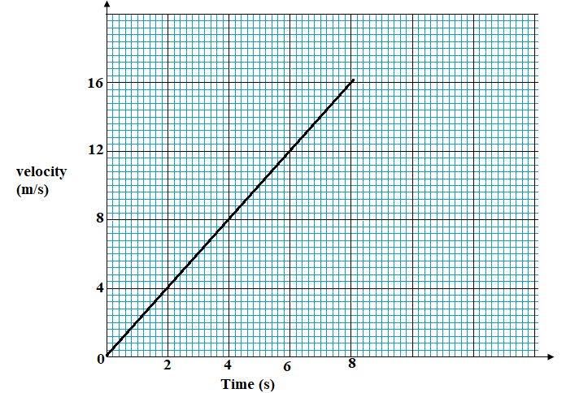
Figure 1
- What does the area under the graph represent? ________________________________________________________________________________________________________________________________________ (1 mark)
Continued/…
ii. Describe how acceleration of a trolley can be determined using the graph. ____________________________________________________________________________________________________________________________________________________________________________________________________________ (3 marks)
- a. Define the term “derived quantities”
__________________________________________________________________________________________________________________________________________________
(1 mark)
b. Calculate the actual reading of an ammeter with an error of -0.2A that was used to
measure electric current of 2.3A in an electric circuit.

(2 mark)
c. What fraction of Stontium-90 produced in 1963 (half-life = 29years)
remained in 2021?

(1 mark)

- a. State Faraday’s law of electromagnetic induction.
___________________________________________________________________________________________________________________________________________________________________________________________________________________________
(1 mark)
Continued/…
b. Figure 2 is a simple transformer.
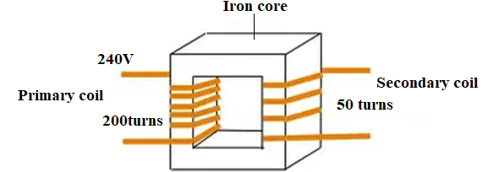
Figure 2
- Calculate the output voltage.

(2 marks)
- What type of transformer is shown in figure 2? _______________________________________________________________________
(1mark)
- Give any one factor that affects the magnitude of an induced electromotive force. ______________________________________________________________________________________________________________________________________________ (1 mark)
- a. State energy- work theorem.
__________________________________________________________________________________________________________________________________________________
(1 mark)
Continued/…
b. Figure 3 shows an oscillating pendulum.
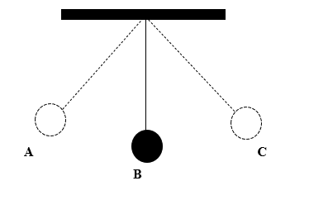
Figure 3
- At which positions does the pendulum have no kinetic energy? _______________________________________________________________
(1 mark)
- Where does the pendulum have maximum speed? ________________________________________________________________
(1 mark)
- Describe the energy changes from point A to point B. ________________________________________________________________________________________________________________________________ (2 marks)
- a. Define the term principal axis of a lens.
__________________________________________________________________________________________________________________________________________________
(1 mark)
b. An object 25cm high is placed 40cm in front of a converging lens of focal length 60cm.
- Draw a ray diagram and find the position of the image formed.
(Use a scale of 1cm: 20cm)

(4 marks)
Continued/…
- Describe the nature of the image formed. _________________________________________________________________________________________________________________________________________________________________________________________________________ (3 marks)
- a. Define the term kilowatt-hour
__________________________________________________________________________________________________________________________________________________
(1 mark)
b. An electric kettle is rated 400W, 220V and when filled with cold water take 30 minutes
to boil. Calculate,
- the current through the kettle when it works normally

(2 marks)
- The cost of using the element if 1 unit of electricity cost MK650.

(3 marks)

Continued/…
c. An echo sounder sends sound signals to the bottom of a lake and receives the sound
echo after 10.0 seconds. If the speed of sound in water is 5,000 m/s, calculate the depth
of the lake at that point.

(3 marks)
- a. State any one property of waves.
_________________________________________________________________ (1 mark)
b. Figure 4 shows a wave. Study it and answer the questions that follow;
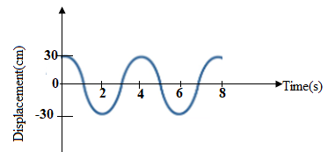
Figure 4
- Name the type of wave in figure 4. _________________________________________________________ (1mark)
- Calculate the velocity of the wave if its wavelength is 50m.

- marks)
Continued/…
- a. What is a semiconductor?
__________________________________________________________________________________________________________________________________________________
(1 mark)
b. Explain any one application of law of inertia.
________________________________________________________________________________________________________________________________________________
(2 marks)
c. Figure 5 shows a logic gate.
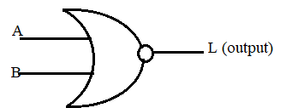
Figure 5
- Name the type of gate _________________________________________________________ (1 mark)
- Draw the truth table for the logic gate

(2 marks)
- a. A gas has volume of at . To what temperature must it be heated to double its volume at constant pressure?

(3 marks)
Continued/…
b. State the law used in question 9(a) above.
__________________________________________________________________________________________________________________________________________________ (2 marks)
c. A lever is used to lift a load of 500N. An effort of 100N is applied 3m from the fulcrum.
The load is 1.5m from the fulcrum. Calculate
- the mechanical advantage

(2 marks)
- the velocity ratio

(3 marks)
- the efficiency of the lever

(3 marks)
- a. Describe any two methods of safely storing radioactive waste. ________________________________________________________________________________________________________________________________________________________________________________________________________________________ (2 marks)
Continued/…
b. Two identical springs connected in parallel with an object of unknown mass X produces the total extension of 5cm. Calculate the mass in kg of the object, if the spring constant of each is 5N/cm

(5 marks)

SECTION B (30 MARKS)
Answer all and three questions in this section in the spaces provided.
- a. With the aid of a labelled diagram, describe how a steel bar can be magnetized by single stroking method.

________________________________________________________________________________________________________________________________________________
________________________________________________________________________________________________________________________________________________________________________________________________________________________________________________________________________________________________________________________________________________________________________
(5 marks)
Continued/…
b. Describe how a plumber can join two metallic pipes of same diameter.
________________________________________________________________________________________________________________________________________________________________________________________________________________________________________________________________________________________________________________________________________________________________________________________________________________________________________________________________________________________________________________________________________________________________________________________________
(5 marks)
- a. Explain the way a simple camera works.
________________________________________________________________________________________________________________________________________________________________________________________________________________________________________________________________________________________________________________________________________________________________________________________________________________________________________________________________________________________________________________________________________________________________________________________________________________________________________________________________________________________________________________________________________________________________________________________________________________________________________________________________________________________________________________________________________________________________________________________________________________________________________________________________________________________________________________________________________________________________________________________________________________________________________________________________________
(6 marks)
Continued/…
b. Show that .

(4 marks)
- a. Describe how the average speed of an athlete could be determined. ________________________________________________________________________________________________________________________________________________________________________________________________________________________________________________________________________________________________________________________________________________________________________________________________________________________________________________________________________________________________________________________________________________________________________________________________ (5 marks)
b. Describe how a falling object in fluid reaches terminal speed.
________________________________________________________________________________________________________________________________________________________________________________________________________________________________________________________________________________________________________________________________________________________________________________________________________________________________________________________________________________________________________________ (5 marks)
END OF QUESTION PAPER
NB: This paper contains 12 printed pages.

